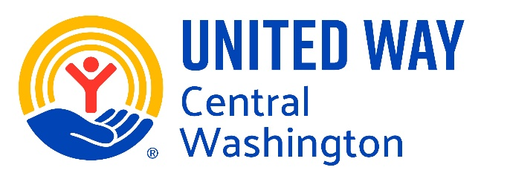 May 2026
Dear DPIL Families,

It is with a very heavy heart that we write to share difficult news regarding the Dolly Parton’s Imagination Library program in Yakima and Kittitas Counties.

After several years of serving as the local affiliate, United Way Central Washington (UWCW) must formally withdraw from the program. As a result, the June 2026 mailing will be the final Imagination Library book your child will receive through our local program. The program will officially cease operating in Yakima and Kittitas Counties as of June 30, 2026.

We know how meaningful these books have been to your family. For many children, the arrival of a new book each month has been a moment of excitement, bonding, and early learning. Ending this program is not a decision we have made lightly.

Over the past several years, enrollment in the program has grown exponentially — a testament to the value families place on early literacy. Unfortunately, while participation has increased, financial support has steadily declined.

There is a common misconception that Dolly Parton personally, or the Imagination Library Foundation, fully funds local programs. While the Foundation provides administrative infrastructure and secures publishers, local affiliates are responsible for raising the funds needed to cover book costs, mailing, and program administration in their communities. UWCW does not receive funding from the Foundation to cover these local costs or overhead, which have risen significantly in recent years.

In addition, the State of Washington — which previously helped fund approximately 50% of program costs — has withdrawn financial support due to the state’s current fiscal state. Despite extensive outreach and conversations with local businesses, agencies, and government partners, we have been unable to secure the financial commitments necessary to sustain the program moving forward.

Without funding from the Foundation, the withdrawal of state support, and no confirmed local investment sufficient to close the gap, the program has become fiscally unsustainable. UWCW simply cannot continue to absorb the full cost of the program alone.

We share this news with sadness, but also with transparency. Our responsibility is to ensure that the programs we operate are financially sound and sustainable for the long term. Continuing under current conditions would jeopardize other critical services in our community.

While the closure of the local Imagination Library program is disappointing, we encourage families to continue fostering a love of reading through other local resources:
- Yakima Valley Libraries – Free library cards, story times, early literacy programming, and book lending for all ages.
- Kittitas County Libraries – Free access to books, early learning programs, and family literacy events.
- Local early learning centers and school district family engagement programs
- Head Start and ECEAP programs serving eligible families
- Community book drives and literacy events throughout the year
- Little Libraries
- School programs and events

Your local library remains one of the most powerful free resources available to families, and we strongly encourage you to connect with them if you have not already done so.

We are deeply grateful to every family who has participated in this program and to the many supporters who made it possible for as long as it operated. It has been an honor to help deliver books — and joy — to children across Yakima and Kittitas Counties.

If you have questions, please contact UWCW at info@uwcw.org.

With appreciation and sincere regret,

Your United Way Central Washington Family

